Alabama Board of Rehabilitation Services
Alabama Department of Rehabilitation Services
560 South Lawrence Street
Montgomery, Alabama
Executive Session (In-Person)
Minutes
Thursday, Dec. 2, 2021

Call to Order:
Mr. Eddie Williams, Board Chair, called the executive session to order at 11:24 a.m.

Verification of Quorum:
Board members present (in-person): Mr. Eddie Williams, Board Chair; Mrs. Penny Foster, Board Vice-Chair; Mr. Kevin Kidd; Mr. Jimmie Varnado; and Mr. Charles Wilkinson. A quorum was declared.

New Business:

Commissioner Burdeshaw and members of the Alabama Board of Rehabilitation Services discussed recent personnel changes and their impact on programmatic matters concerning the Department.
There being no further business, the meeting was adjourned at 11:45 a.m.
Minutes were taken by Karen Freeman.

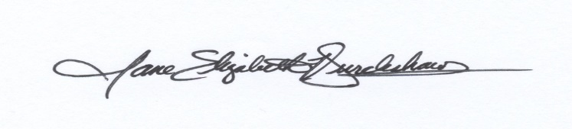
Respectfully submitted: ____________________________________ Jane E. Burdeshaw, Commissioner
Approved: _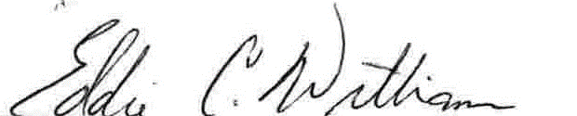_____________________________________ Eddie C. Williams, Chair

